Just Stand Up
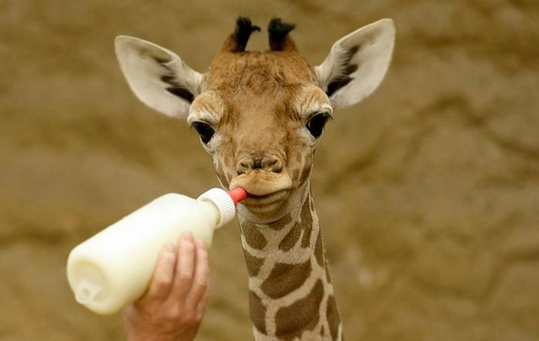
If you were a new born giraffe, your first moments in the world would be hard.
First, you will probably fall 10ft from your Mums womb. Second, you would tuck in your tiny giraffe hoofs and try to shake all that birthing fluid from your eyes, ears and nose and try to stand up.
And try.
And try some more.
You’re wobbly.
You fall down.
Try some more.
You don’t get up.
Eventually you make it.
You will receive no encouragement from Mum way up there, she will just stand and watch, maybe she may give you a lick or two but that’s it.
No Fisher Price toys for you to lean on as you take those steps or a sofa to prop yourself against. No grandparents, aunts or uncles giving you a round of applause.
As soon as you make it to standing, and Mum sees your success — which has been hard enough with those long legs of yours. Your Mum would then does the unspeakable — she knocks you over.
Back to where you started.
So you have to go through the whole process again.
You try to stand up.
And try some more.
You’re wobbly.
You fall down.
Try some more.
You don’t get up.
You make it.
Next. She repeats the knock. Again you repeat the standing.
Over and over she knocks you down until eventually you can get up quick with no wobble, no falling, no hesitation.
She does this for her love for you.
All her instincts tell her that in the wild if you can’t get up in a split second and move with the group when danger strikes, you won’t survive. You’re toast. Well, dinner for another animal. Maybe not toast!
She doesn’t want you to just learn.
She wants you learn and remember what to do.

Moral?
When life kicks you hard when you least expect it. Get up. Stand up. Try again. Trust yourself that no matter the odds you can pull yourself up.
Whether kicked, beaten, down trodden, ridiculed, belittled, judged, mocked … stand up every time. Every. Time.
Sure, you can lie down on the mental ground and think, ‘Why the hell is this happening to me over and over again?‘. Just stand up.
You, me, everyone we all need to learn, the way we learn has nothing to do with the techniques or methods, the beautiful thing about learning is we already know instinctively what we need to do.
Stand up. Stand up with your whole self: mind and body. You know this learning. Instinctively, you know.
Your Thoughts:

